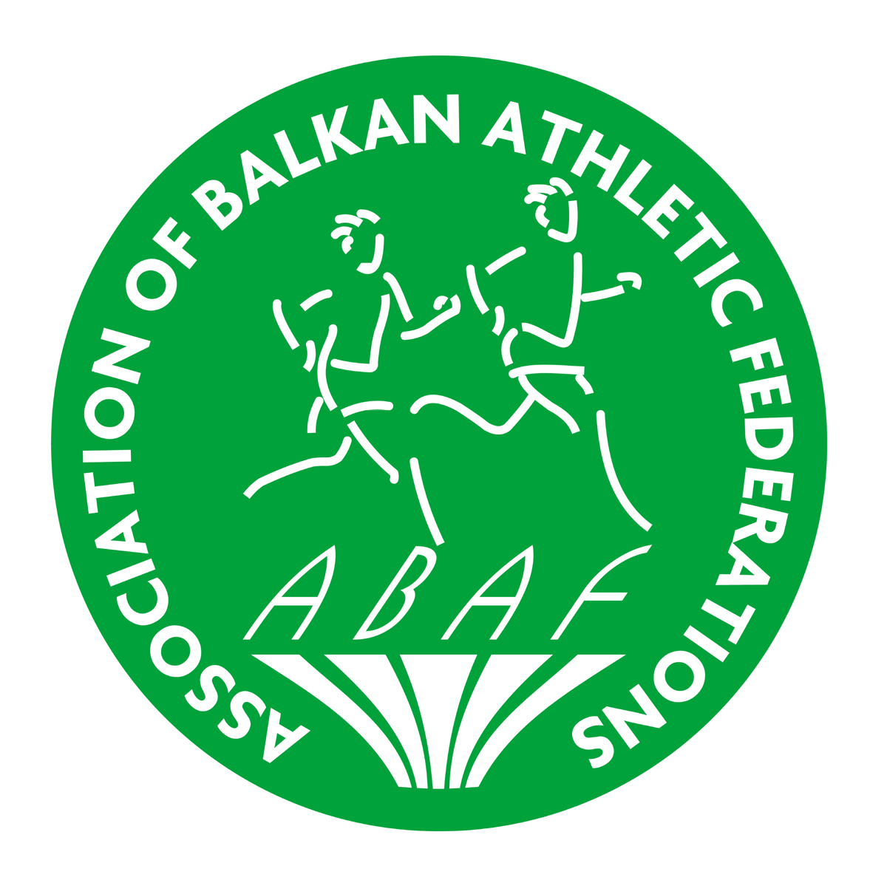 | BALKAN U18 ATHLETICS  CHAMPIONSHIPS  Istanbul - TUR  03 June 2017 | 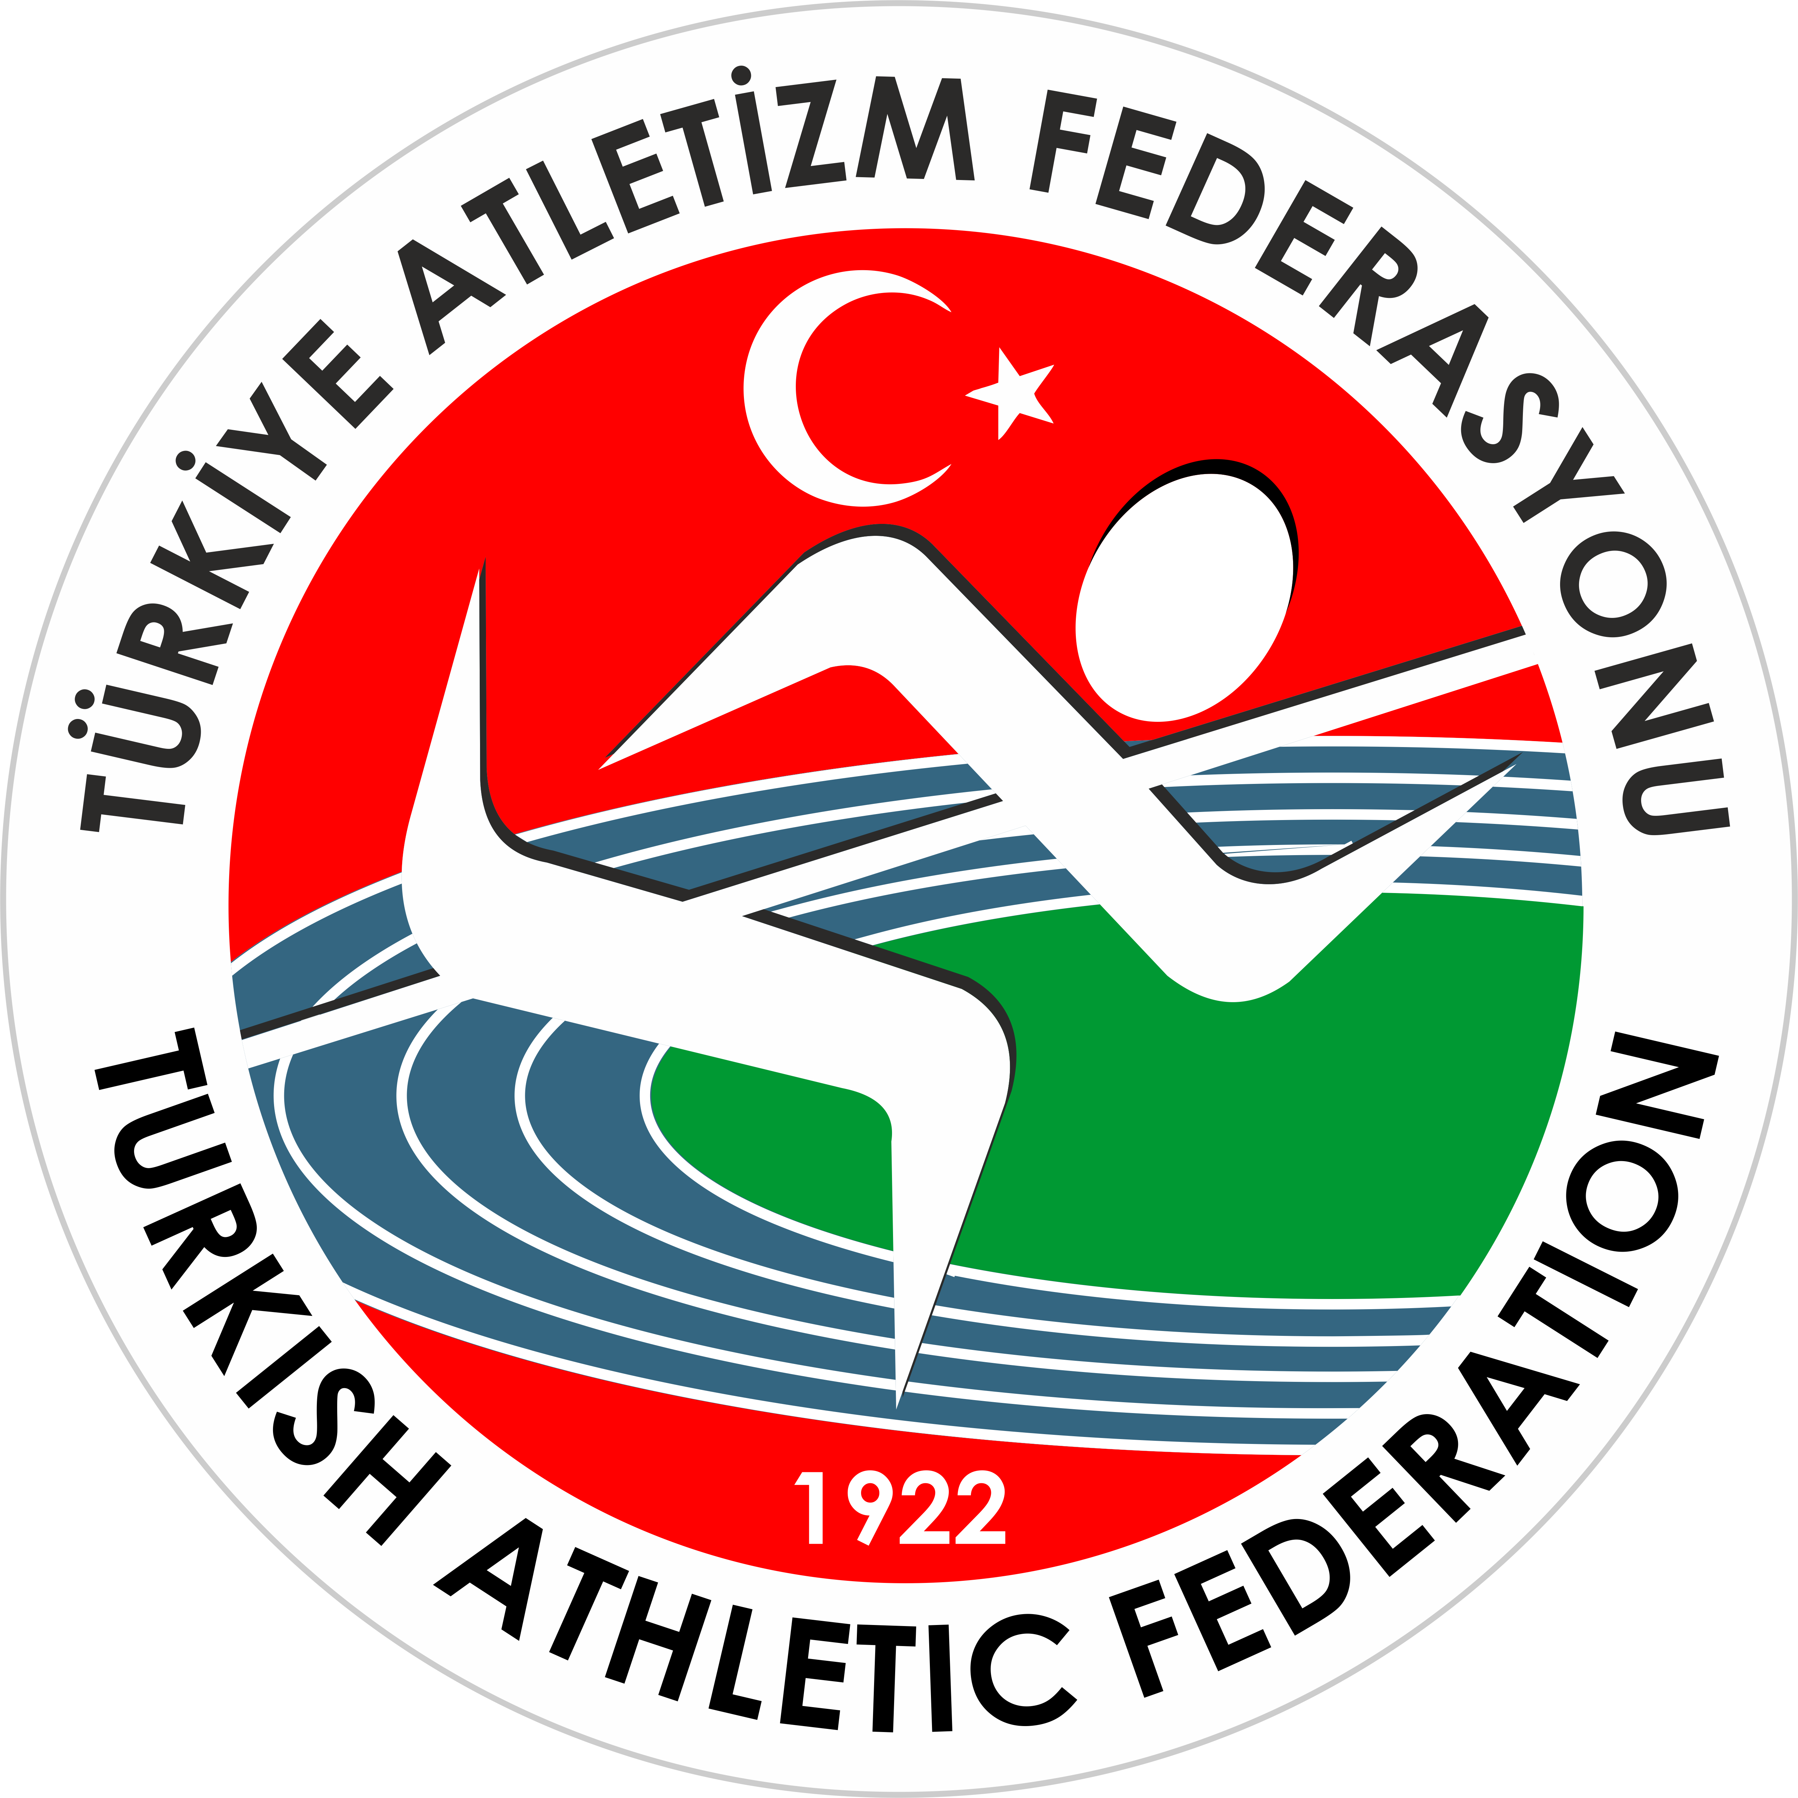

PRELIMINARY ENTRY FORM
Country:
Country Code:

 | MEN | WOMEN | TOTAL
Competitors
Team leaders
Technical leaders
Officials
Coaches
Doctors
Physiotherapists
Driver
TOTAL

Arrival |  |  | Departure
Date of arrival |  |  | Date of departure
Time of arrival |  |  | Time of departure
Means of transport |  |  | Means of transport

Please return this form to tur@mf.iaaf.org ; atletizmtr@yahoo.com ; ugur.kucuk@taf.org.tr burak.darici@taf.org.tr no later than May 15th, 2017

Name |  | Position
Signature |  | Date

